I. OSNOVNI PODATKI

Osnovna šola:  Solkan | Oddelek, skupini:  8. a, 8 1 in 8 2 | Učitelji, ki izvajajo učno enoto:  - Luka Pavlin | Število ur: 3 ure/skupino  Datumi izvedb: 1. 12., 2. 12., 3. 12. (skupina 8-1), 1. 12., 3. 12., 4. 12.  (skupina 8-2).
Naslov učne enote: Raziskujemo epidemije |  | Učitelji, ki izvajajo učno enoto:  - Luka Pavlin
Cilji in standardi iz UN po predmetih:
Predmet: Angleščina | Cilji:  Učenci ob branju kompleksnejših besedil utrjujejo rabo preprostih bralnih strategij in razvijajo kompleksne bralne in učne strategije (predvsem razumevanje, interpretacijo idej in podatkov v besedilih, sklepanje in tudi vrednotenje); svoje ugotovitve se učijo podpreti z dokazi iz besedila. | Standardi:  Učenec razume glavno misel besedil z osebnega in delno širšega tematskega področja; razume jasno izpostavljene, izražene podrobnosti v besedilih; poišče v daljšem besedilu določene podatke (ki jih potrebuje za izpolnitev zastavljene naloge); prepozna in razume nebesedne okoliščine (npr. sporočilni namen, mnenje, neposredno izraženo v besedilu itn.); oblikuje in preprosto razloži svoj odnos do prebranega besedila.

Vključeni predmeti:  - Angleščina | Uporabljena digitalna orodja:  - LiveWorksheets,  - Google dokumenti,  - Mentimeter. | Izbrane STEM-kompetence (2):  - REŠEVANJE PROBLEMOV  - INOVATIVNOST IN USTVARJALNOST  - KOMUNIKACIJA  - SODELOVANJE  - SAMOURAVNAVANJE  - KRITIČNO MIŠLJENJE  - METAKOGNITIVNE VEŠČINE  - PREDMETNE VEŠČINE/KOMPETENCE | Uporabljena načela načrtovanja STEM-učne enote:  - REŠEVANJE PROBLEMOV  - PREDMETNA IN MEDPREDMETNA ZNANJA  - INŽENIRSKI PRISTOP  - SMISLENA RABA TEHNOLOGIJE  - REALNE, ŽIVLJENJSKE SITUACIJE  - USTREZNE UČNE METODE

III. NATANČNO NAČRTOVANJE STEM-UČNE ENOTE OZ. DEJAVNOSTI (Opomba: za prečne veščine obarvamo modro – mi smo zeleno, da se ne meša s hiperpovezavo)
Korak | OBLIKOVANO/NAČRTOVANO SKUPAJ Z UČENCI
Korak | Nameni učenja:  Učim/-o se: | Učne dejavnosti (metode in oblike):  - ¹ime/naslov dejavnosti  - ²opis dejavnosti učenca  - ³priloge (oznaka, ime) | Kriteriji uspešnosti:  Uspešen/-a bom, ko bom: | Dokazi (pridobljeni tudi z IKT):  - ki izhajajo iz pogovorov med poukom  - ki izhajajo iz opazovanj  - izdelki
I.  I/2.2 |  | TJA, Coronavirus and Social media  Na (prirejenem) besedilu Coronavirus has forced us to spend our time online (priloga I/2.2.1) se je učence usmerilo v probleme, povezane s pandemijo covida - predvsem gre za odpiranje družbene razsežnosti v smislu, kako so se spremenili vzorci obnašanja v času pandemije. Znotraj kritičnega mišljenja so učenci zavzemali različne perspektive (implicitni način poučevanja).  Dejavnosti MED branjem:  Med prvim branjem učenci preletijo besedilo, prepoznajo neznane besede, ki jih nato razložijo in po potrebi besedilo še večkrat preberejo. Nato sledi poglobljeno branje in reševanje učnega lista na platformi LiveWorksheets (gl. prilogo I/2.2.1), v katerem odgovarja tako na naloge bralnega razumevanja kot tudi na naloge, vezane na veščine KM (primerjanje, zavzemanje perspektiv itd.).  Dejavnosti PO branju:  Učenci rešijo vprašalnika v Mentimetru (gl. prilogi I/2.2.2 in I/2.2.3) ter učna lista v Google dokumentih (gl. prilogi I/2.2.4 in I/2.2.5). V slednjih je fokus na učenju veščin KM (zavzemanje perspektiv, postavljanje vprašanj).  - ³Priloga I/2.2.1 izhodiščno besedilo Coronavirus has forced us to spend our time online,  - priloga I/2.2.2 UL Coronavirus and social media v LiveWorksheets,  - priloga I/2.2.3 vprašalnik v Mentimetru – Coronavirus and social media – feelings,  - priloga I/2.2.4 vprašalnik v Mentimetru – Coronavirus and social media – social networks,  - priloga I/2.2.5 UL v Google dokumentih – Coronavirus and social media – additional feedback,  - priloga I/2.2.6 UL v Google dokumentih – Coronavirus and social media – potential problems. | Skupni cilj: (Na)učim se kritično misliti.  Skupni in osebni cilji ter merila uspešnosti so v fazi predznanja postavljeni za razumevanje besedila, ne na veščine KM! | 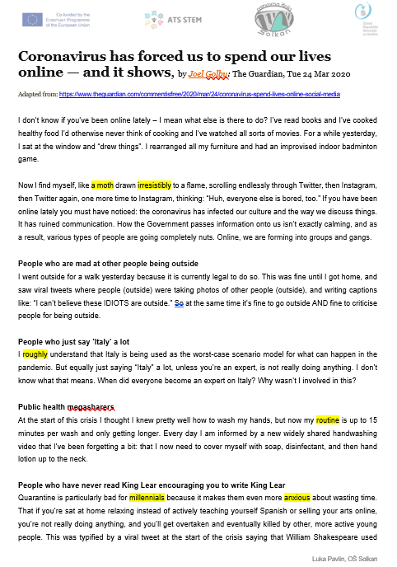  Coronavirus has forced us to spend our lives online – izhodiščno besedilo (priloga I/2.2.1)  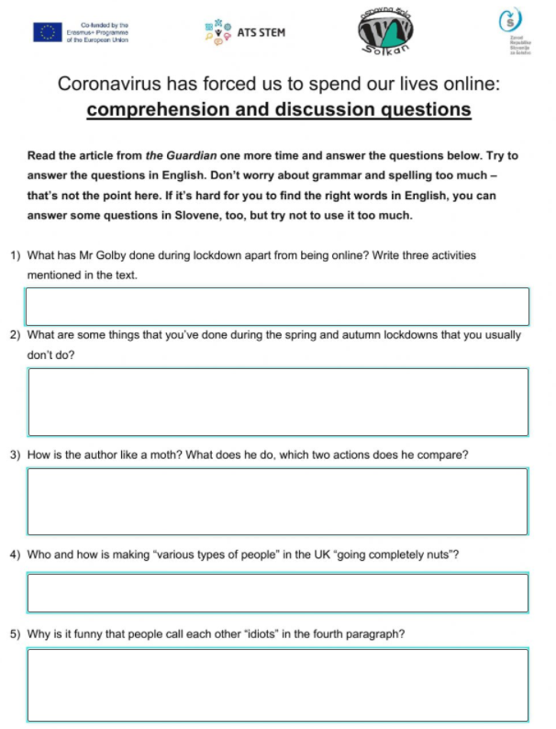  Coronavirus and social media – UL v LiveWorksheets (priloga I/2.2.2)  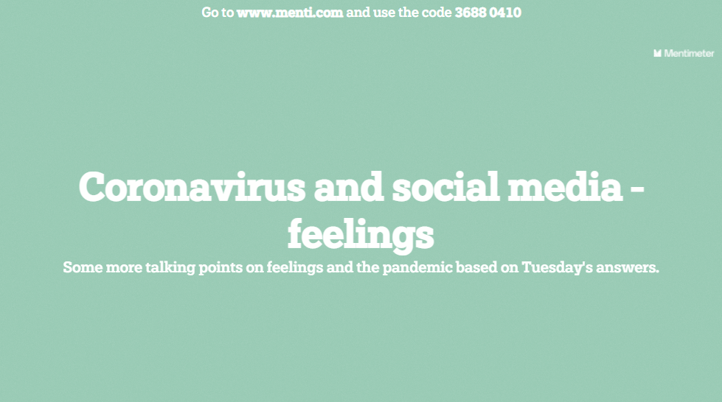  Coronavirus and social media – feelings – vprašalnik v Mentimetru (priloga I/2.2.3)  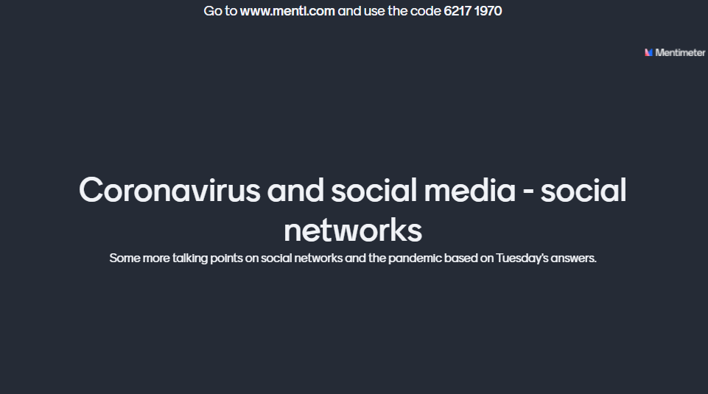  Coronavirus and social media – social networks – vprašalnik v Mentimetru (priloga I/2.2.4)  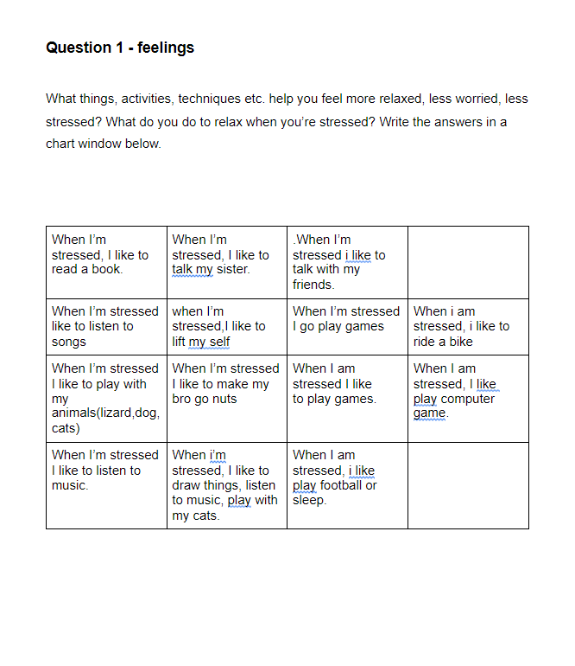  Coronavirus and social media – additional feedback – UL v Google dokumentih (priloga I/2.2.5)  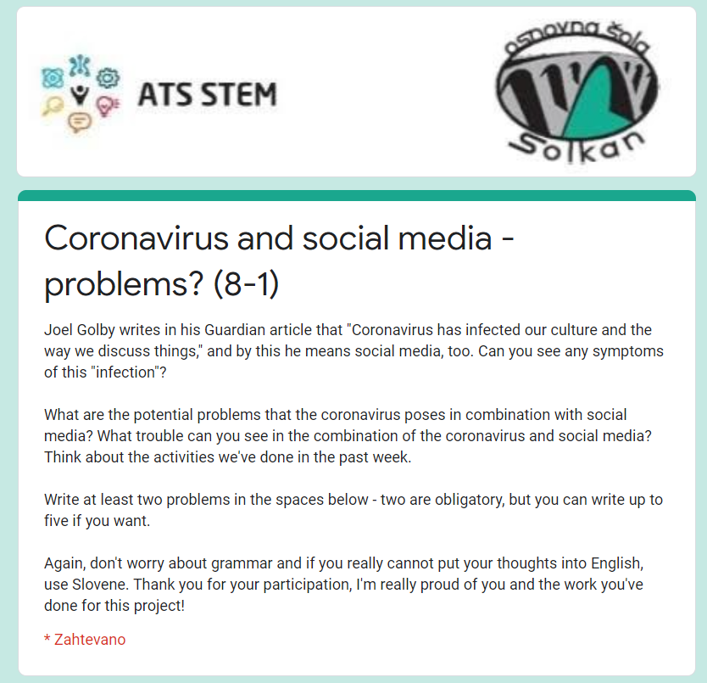  Coronavirus and social media – potential problems – UL v Google dokumentih (priloga I/2.2.6)

I/2.2 Učni listi pri TJA,
I/2.2.1: izhodiščno besedilo Coronavirus has forced us to spend our time online

Coronavirus has forced us to spend our lives online — and it shows, by Joel Golby: The Guardian, Tue 24 Mar 2020

Adapted from: https://www.theguardian.com/commentisfree/2020/mar/24/coronavirus-spend-lives-online-social-media

I don’t know if you’ve been online lately – I mean what else is there to do? I’ve read books and I’ve cooked healthy food I’d otherwise never think of cooking and I’ve watched all sorts of movies. For a while yesterday, I sat at the window and “drew things”. I rearranged all my furniture and had an improvised indoor badminton game.

Now I find myself, like a moth drawn irresistibly to a flame, scrolling endlessly through Twitter, then Instagram, then Twitter again, one more time to Instagram, thinking: “Huh, everyone else is bored, too.” If you have been online lately you must have noticed: the coronavirus has infected our culture and the way we discuss things. It has ruined communication. How the Government passes information onto us isn’t exactly calming, and as a result, various types of people are going completely nuts. Online, we are forming into groups and gangs.

People who are mad at other people being outside
I went outside for a walk yesterday because it is currently legal to do so. This was fine until I got home, and saw viral tweets where people (outside) were taking photos of other people (outside), and writing captions like: “I can’t believe these IDIOTS are outside.” So at the same time it’s fine to go outside AND fine to criticise people for being outside.

People who just say ‘Italy’ a lot
I roughly understand that Italy is being used as the worst-case scenario model for what can happen in the pandemic. But equally just saying “Italy” a lot, unless you’re an expert, is not really doing anything. I don’t know what that means. When did everyone become an expert on Italy? Why wasn’t I involved in this?

Public health megasharers
At the start of this crisis I thought I knew pretty well how to wash my hands, but now my routine is up to 15 minutes per wash and only getting longer. Every day I am informed by a new widely shared handwashing video that I’ve been forgetting a bit: that I now need to cover myself with soap, disinfectant, and then hand lotion up to the neck.

People who have never read King Lear encouraging you to write King Lear
Quarantine is particularly bad for millennials because it makes them even more anxious about wasting time. That if you’re sat at home relaxing instead of actively teaching yourself Spanish or selling your arts online, you’re not really doing anything, and you’ll get overtaken and eventually killed by other, more active young people. This was typified by a viral tweet at the start of the crisis saying that William Shakespeare used quarantine to write King Lear, which made everyone who is in any way creative feel that, if they don’t leave this lockdown with at least one masterpiece, they’ve wasted the one chance they had to do it.

Crises are meant to bring out the best of us, but right now I’m looking at the chaotic queues outside the supermarket across the road and scanning a social media full of people screaming at photos of parks and wondering if all this is really happening. I think I’m just going to get on with my badminton.

GLOSSARY
- a moth = an insect similar to a butterfly that flies at night and is attracted to light (vešča);
- irresistibly = in a way that you cannot stop (neustavljivo);
- roughly = not exactly (približno);
- a routine = a usual, fixed way of doing things (postopek, rutina);
- a millennial = a person born in the 1990s or early 2000s, someone who’s in their twenties right now (milenijec);
- anxious = worried and nervous (tesnoben, zaskrbljen);
- King Lear = one of the most famous tragedies by Shakespeare (Kralj Lear).

I/2.2.2: UL Coronavirus and social media v LiveWorksheets

Coronavirus has forced us to spend our lives online: comprehension and discussion questions
Read the article from the Guardian one more time and answer the questions below. Try to answer the questions in English. Don’t worry about grammar and spelling too much – that’s not the point here. If it’s hard for you to find the right words in English, you can answer some questions in Slovene, too, but try not to use it too much.

- What has Mr Golby done during lockdown apart from being online? Write three activities mentioned in the text.

- What are some things that you’ve done during the spring and autumn lockdowns that you usually don’t do?

- How is the author like a moth? What does he do, which two actions does he compare?

- Who and how is making “various types of people” in the UK “going completely nuts”?

- Why is it funny that people call each other “idiots” in the fourth paragraph?

- Imagine you have just finished school and you’re a young person starting a career right now in lockdown. How do you feel about your chances?

- The author’s opinion on the use of social media in lockdown in the UK is negative. How can you use social networks like the ones mentioned in the text (Instagram, Twitter, etc.) in a positive way? Which social networks do you use most and what do you do on them?

- Do you think Covid-19 can be dangerous to you? How is your opinion shaped by what you see/hear on TV, on the radio, online, etc.? How is it shaped by the people you know (parents, friends, teachers …)?

I/2.2.3: Coronavirus and social media – feelings – vprašalnik v Mentimetru: https://www.mentimeter.com/s/f3f71104a2a758f4ba271c46384355cb/209279cc6e80

I/2.2.4: Coronavirus and social media – social networks – vprašalnik v Mentimetru: https://www.mentimeter.com/s/9721d88c5441ad978842a15541fb8973/835b44a296de

I/2.2.5: Coronavirus and social media – additional feedback – UL v Google dokumentih: https://docs.google.com/document/d/1jfA0q726xsVGcbvI6BNd0-1hN6OsgVUiTVLC9fUaiXI/edit?usp=sharing

I/2.2.6: Coronavirus and social media – potential problems – UL v Google obrazcih: https://docs.google.com/forms/d/e/1FAIpQLSciGbgrSiBYrrVf8oSxTW_26YCZs5PHzcJnoYmorAsZIbWZTA/viewform

V. EVALVACIJA STEM UČNE ENOTE – ni vključena v tem delu, ker je slednji vezan na fazo predznanja.

