Barbara Ann (The Beach Boys)

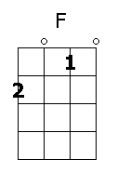
F
A Bar bar bar bar Barbara Ann

Bar bar bar bar Barbara Ann

F Bb
Oh Barbara Ann take my hand
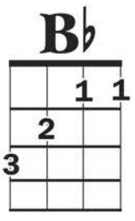
F
Barbara Ann
C
You got me rockin' and a rollin'
Bb F
Rockin' and a reelin' Barbara Ann

Bar bar bar bar Barbara Ann

F
Went to a dance looking for romance
F7
Saw Barbara Ann so I thought I'd take a chance
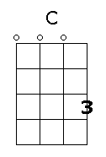
Bb
On Barbara Ann Barbara Ann
F
Oh take my hand Barbara Ann Barbara Ann
C
You got me rockin' and a rollin'
Bb F
Rockin' and a reelin' Barbara Ann
F
Bar bar bar bar Barbar Ann

