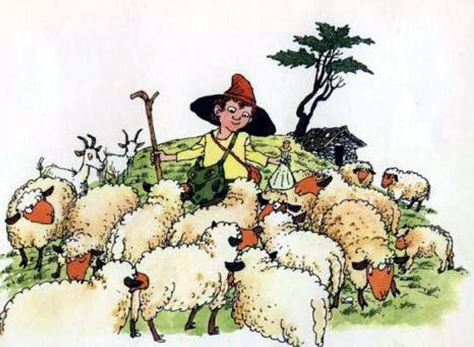
IZIDOR OVČICE PASEL

C G C
Iizidor ovčiice pasel,
G C
leepo žvižgal, leepo pel,

C G
cingel cing cingel cingel cong,
C
cingel cing cingel cingel cong,
G
cingel cing cingel cingel cong,
C
cingel cing cong.

C G C
Koo ovčice jee napasel,
G C
stoopil je v vojaaški stan,

C
cingel ...

