
Jingle Bells
(J. Pierpont)
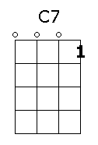

F B
Dashing through the snow, in a one-horse open sleigh.
C7 F
Over fields we go, laughing all the way.
F B
Bells on bobtails ring, making spirits bright.
C7 F
What fun it is to ride and sing a sleighing song to-night , oh!
F

Jingle bells, jingle bells, jingle all the way,
B C7
Oh what fun it is to ride in a one-horse open sleigh, hey!
F
Jingle bells, jingle bells, jingle all the way
B C7 F
Oh what fun it is to ride in a one-horse open sleigh.

