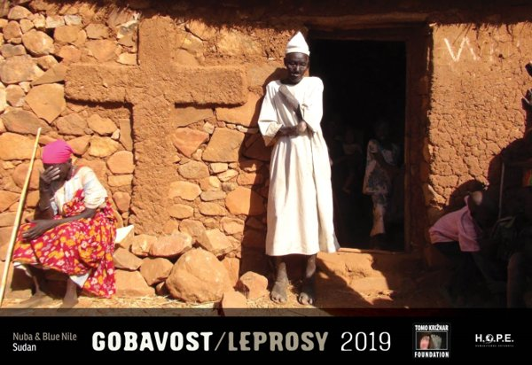
V času snemanja žrtev nove množične lakote v Nubskih gorah januarja letos sva skozi objektive najinih kamer nenadoma zagledala prazne oči. Obraze brez ušes. Roke in noge brez prstov.
Tam visoko nad savano, so pred nama trohneli ljudje!
Bolni, sestradani,izčrpani soljudje, za katere nihče ne ve in sva jim bila midva prva in do danes edina priča! Za gnusno trohnenje teles v Nubskih gorah in Modrem Nilu je odgovorno sramotno trohnenje vrednot, src, zavesti in vesti privilegiranega dela človeštva, ki se še naprej spopada v svojih proxy vojnah na hrbtih nedolžnih staroselskih ljudi za nadzor naravnih virov na plemenskih ozemljih. Pa tudi agencije in organizacije ki do danes še niso odreagiralo na naše klice na pomoč!
Za vse vas, ki vam je še mar, pripravljamo nov dokumentarni film, ki bo, upamo, prepričal tudi uradnike WHO in OZN, da bodo opravili svojo dolžnost.
Z nakupom tega koledarja boste pomagali zaustaviti širjenje gobavosti!
Novi koledar Ustanove Tomo Križnar in humanitarne organizacije Hope za leto 2019 lahko naročite: tomo.narocila@gmail.com
Cena: 9 EUR + poštnina
Dobava: takoj
Plačilo na TRR Ustanove Tomo Križnar: SI56 0510 0801 3175 987
BIC: ABANSI2X (račun bo priložen k pošiljki).
Pomagate nam lahko tudi tako, da Ustanovi namenite del vaše dohodnine. Povezava do obrazca: OBRAZEC za namenitev dela dohodnine Ustanovi Tomo Križnar
Prosim, pomagajte nam širiti to sporočilo.
Najlepša hvala za sodelovanje in srečno novo leto 2019
Tomo in Bojana Križnar
www.TomoKriznar.com
***************************************************** ENGLISH *****************************************************
Looking through the lenses of our cameras, as we filmed the victims of the new mass starvation in the Nuba mountains in January, we suddenly
saw those empty eyes. Faces without ears. hands and feet without fingers and toes.
There, high above the savanna, in front of the mud and straw building of the coptic church on mount Acheron, people were rotting before
our very eyes!
Sick, starving, exhausted fellow humans that nobody knows about, we were their first and so far only witness. The responsibility for the disgusting disintegration of human bodies in the Nuba mountains and Blue Nile lies in the shameful disintegration of values, hearts, consciousness and conscience of privileged humanity in the raging conflicts between all the major global economic and military elites for control over natural resources, and the simultaneous siege and extermination of the Nuba, the most innocent indigenous African people.
For all of you that still care, we are working on a new documentary. We hope it will also convince WHO and UN officials to carry out their duty.
Please buy this calender and help us to finish the production of documentary film and stop spreading leprosy.
Order calendar: tomo.narocila@gmail.com
Price: 9 EUR + posting
Account Number Fundation Tomo Križnar: SI56 0510 0801 3175 987
BIC: ABANSI2X (Account will be attached to the shipment).
Please help to spread this message.
Thank you for your cooperation.
We wish you happy new year.
Tomo in Bojana Križnar
Www.TomoKriznar.com

