POTOVANJE V NEZNANO / Kako potujete pri odnosnih ciljih predmeta?
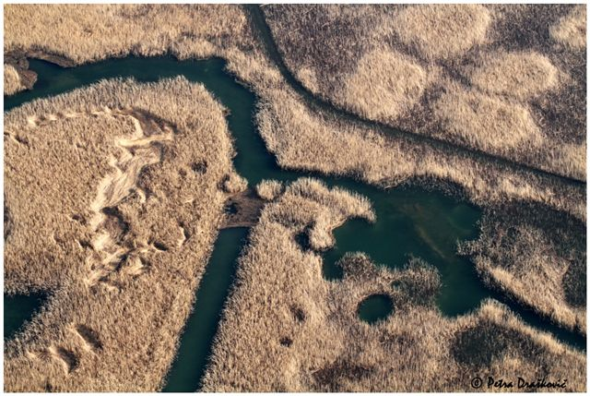
Life Vest Inside - Kindness Boomerang - "One Day" - YouTube
The Power of Words - YouTube
Morgan Freeman: The Power of Words - YouTube

http://www.youtube.com/watch_popup?v=nwAYpLVyeFU&vq=medium#t=77
http://www.youtube.com/watch?v=Hzgzim5m7oU

