How To Use iTALC with Userful MultiSeat™

Content
- 1 Introduction
- 2 About iTALC
- 3 Installing iTALC
  - 3.1 Installing iTALC Master, Client and libitalc Components
  - 3.2 Getting and Installing Userful's iTALC Integration Package
- 4 Setting Up iTALC
  - 4.1 Adding Client (Student) Computers to the Classroom Screen
- 5 Manual Configuration
- 6 Using iTALC

Introduction

iTALC is an open source classroom control tool. iTALC stands for "Intelligent Teaching And Learning with Computers" and can be a valuable addition to your organization’s computer-based learning environment. It is a free download for Linux that allows for remote management features to be used by teachers to improve computer instruction and control computer use in the classroom.
This "How To" describes the steps required to install and configure iTALC to run with Userful MultiSeat.
Please Note: iTALC can be used with all versions of Userful Multiseat for the maximum supported number of stations if using USB multiseat devices or multiple video cards.
Using iTALC with USB-over-LAN (network) multiseat devices, with system configurations of more than 1 onboard + 10 network multiseat devices, is not recommended.
- When network stations are used with iTALC, race conditions tend to arise in the kernel leading to system instability. This effect is seen most often when multiple stations are logged in or out in rapid succession. Problems are more likely to occur with higher numbers of network stations.
Userful recommends thoroughly testing iTALC with Userful MultiSeat with the intended deployment configuration and use cases to determine the optimal configuration.

About iTALC
iTALC allows a teacher to view and control other computers in a network. This facilitates teacher/student interaction and allows teachers to monitor student computing activities. Teachers can:
- Remotely access any individual student's desktop to provide them with immediate hands-on help or coaching.
- Broadcast their screens to all students in the classroom.
- Select an individual student’s screen to broadcast to the rest of the class.
- Lock all student screens, ensuring all eyes are at the front of the class during instructional periods.

Installing iTALC
Note: iTALC and Userful's iTALC integration package are already installed with Userful MultiSeat Linux 2011 v4.1 and earlier. Please skip to Setting Up iTALC.
If Using Userful MultiSeat Linux 5.0, iTALC is not installed by default. Please follow the directions below to install all the necessary components.
In order for iTALC to work:
- Computers must share a network connection.
- A computer that will be used by the teacher (whether it be a PC shared by students in a multiseat configuration, or a stand-alone PC or laptop), must have the italc-master package installed.
- Computers that will be used only by students require the italc-client package.
- Both teacher and student computers require the libitalc package.

Installing iTALC Master, Client and libitalc Components
File:UMsiTALCSynaptic.png
Installation of iTALC packages is most easily done using Ubuntu's built-in package manager. Note that an active internet connection is required.
- Log on to a station as a user with administrative privileges.
- Go to System > Administration > Synaptic Package Manager<t/t> to open Ubuntu's package manager.
- In the search box near the top of the page, enter <tt> italc .
- Make sure that italc-client, italc-master and libitalc are marked for installation by clicking on the checkbox in the S column and selecting "Mark for Installation" from the drop-down menu.
  - If you are using Userful MultiSeat Linux v5.0, the userful-multiseat-italc-plugin will also appear in the list; make sure that it is installed as well. NOTE: Userful MultiSeat must be turned off to successfully install the iTALC integration package.
- Click the Apply button (a green checkmark below the window menu bar).
- Reboot the computer.

Getting and Installing Userful's iTALC Integration Package
To make it easier to use iTALC with stand-alone Userful MultiSeat, Userful provides an iTALC integration package. This package is already installed if using Userful MultiSeat 4.1 and 5.0, and is available through the Synaptic Package Manager ( see above) if using Userful MultiSeat Linux 5.0.
The Userful iTALC integration package must be downloaded manually for Userful MultiSeat 4.0. This package should be saved to the Desktop of a user with admin privileges, and can be installed simply by double-clicking the package icon. NOTE: Userful MultiSeat must be turned off to successfully install the iTALC integration package. (Note: the v4.0-1690 plugin is compatible with the v4.0-1702 Userful MultiSeat release as well.)
To download the iTALC integration package, click on the appropriate link below:
- Userful's iTALC Integration Package - 32-bit
  - 32-bit md5 Checksum
- Userful's iTALC Integration Package - 64-bit
  - 64-bit md5 Checksum

Setting Up iTALC
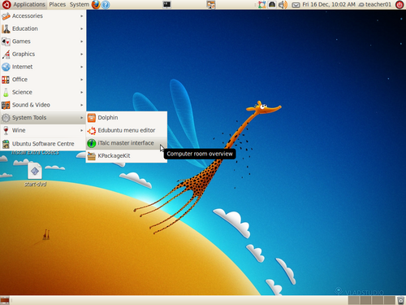
To launch the iTALC Master Program from the onboard station, you must be logged in on an account with administrative privileges (such as the "teacher01" account in Userful MultiSeat Linux; go to Applications > System Tools > iTALC master interface. Alternatively, to launch the iTALC Master program from a USB-multiseat-device-connected station, the terminal must be used. Simply open a terminal and enter the command italc.
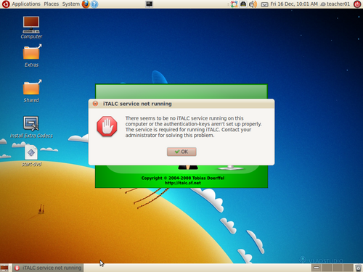
Important: With some system configurations, at least one iTALC client machine must be logged in on the network in order to start the iTALC Master program. If the error message to the right appears when attempting to launch iTALC, simply ensure that at least one iTALC client machine has a user logged into a session. Then launch the iTALC master program as described above.

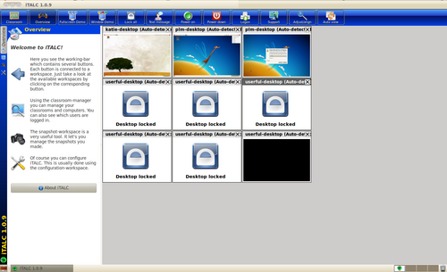
The first time you start the iTALC Master program , it should scan the network for instances of italc-client and display all the clients that are controllable (for example, see the image at right).
Note: If you are using more than one host computer, and if you do not see all of the student screens on the iTALC Master Control screen, you must copy the public and private keys (found in the /etc/italc/keys folder of the teacher's computer) to the /etc/italc/keys/ folder of the student computer(s). Then restart the iTALC Master program.
Important: With some system configurations, stations are autodetected, but don't automatically show up on the iTALC Master interface. If this is the case with your system please skip down to the section below on Manual Configuration.

Adding Client (Student) Computers to the Classroom Screen
With Userful MultiSeat and iTALC v.1.0.9 or greater, computers with italc-client and matching key pairs should be detected automatically and should appear on the iTALC Master Classroom screen. If a small number of client computers are not autodetected, they can easily be added manually. If only the station being used to run the iTALC Master Interface appears on the Master interface, please skip down to the Manual Configuration section below.
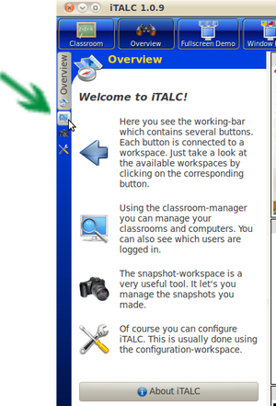
To add computers that are not autodetected manually:
1. Open the Classroom Manager by clicking on the "computer monitor with a magnifying glass" icon on the tabs at the far left of the screen.
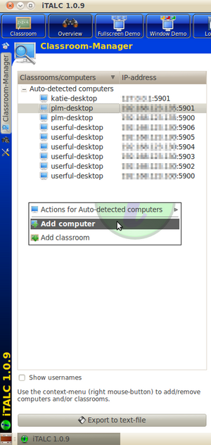
2. The Classroom Manager shows a list of all autodetected computers with their IP addresses. To add a computer manually, right-click in the white space of the Classroom Manager and select "Add Computer".
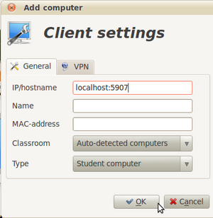
3. Set the IP/hostname to localhost:59xx. Change "localhost" to the target computer's IP and use a port that has not already been claimed by an autodetected computer; ports 5900-5918 are available. If desired, give the italc client a "Name" (note that unless student's have assigned seats, this "Name" should refer to the physical computer station and not to a student).
4. Click the "OK" button. 'Classroom lists are persistent and should only need to be set up once, and then modified if necessary when classroom computer hardware changes.

Manual Configuration
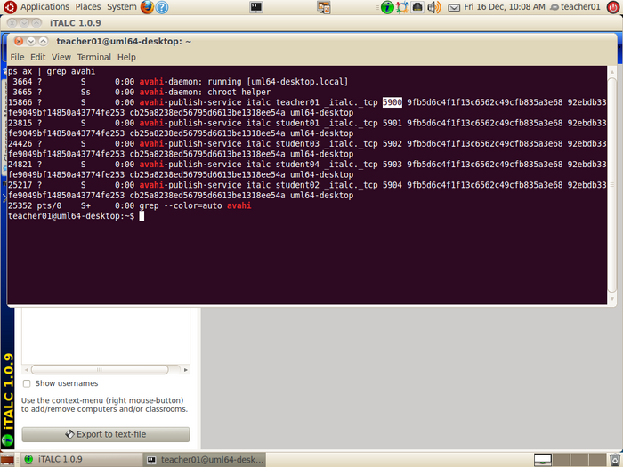
With some system configurations, only the station being used to run the iTALC Master interface shows up on the interface, even though they are being autodetected on the network. If this is the case with your system, it is necessary to use the terminal to show ports being used and manually enter that information into the Classroom Manager. This step should only need to be done once for a classroom unless computer hardware or the network changes.
- Open a terminal and enter the following command to show ports in use (if desired, have users logged into all stations to facilitate mapping physical stations to port numbers):
ps ax | grep avahi
- An example of the output of this command is to the right, with the port number for the 'teacher01' machine highlighted. Take note of the port numbers being used.
- Open the Classroom Manager by clicking on the "computer monitor with a magnifying glass" icon on the tabs at the far left of the screen.
- Follow the directions above to add these clients to the classroom screen.

