https://interestingengineering.com/the-evolution-of-kitchen-appliances-over-time

Hladilnik
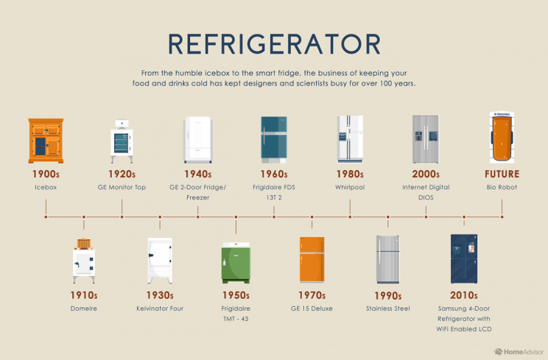Source: Home Advisor
Our refrigerators are finely engineered pieces of tech that are vital to the modern day kitchen. Devices used to keep things cold date back centuries, but the modern day refrigerator began in the early 1900s as an icebox. These metal boxes were lined with a metal like tin and would then be loaded with a massive ice block that would slowly melt as it kept the food in the box cold.
These early ice boxes did the trick, but by around 1915, electric refrigerant style refrigerators began showing up in homes around the world. These early machines functioned on the same principle that modern machines do, cooling through the use of a refrigerant. However, these early devices, called Domeires used a variety of highly toxic gases as refrigerants. That meant that if your refrigerant stopped running, you might too.
Cheesy jokes aside, manufacturers eventually started using Freon in refrigerators near the end of WWII. You'll notice that around the 1940s is when refrigerators took on their modern shape with doors – and not too much has changed since. Nowadays, refrigerators use tetrafluoroethane to keep our food chilled.
Kavni avtomat
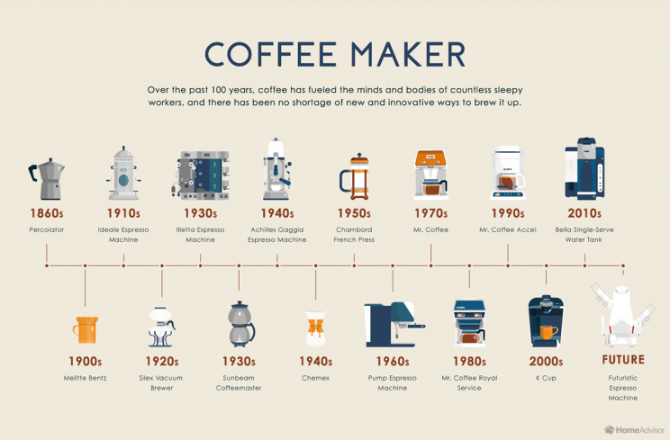Source: Home Advisor
The origins of coffee as a drink date back to the 15th century in Ethiopia and Yemen. These early drinkers likely would've muddled the beans with water and used the drink to stay awake. However, such a manual process would become increasingly unfavorable as the industrial revolution slowly made simple daily processes even easier.
The first "machine" like appliance used for making coffee was the percolator originating in the 1860s. This technique of coffee making evolved until in the 1920s, vacuum system machines were introduced and coffee makers incorporated pumps and filtering systems.
The groovy 1970s brought about the invention of the Mr. Coffee branded coffee maker. While it may be today's budget brand, Mr. Coffee machines were the first in-home drip brewing system for coffee. This invention helped to spread the popularity of coffee across industrialized populations.

Mikser
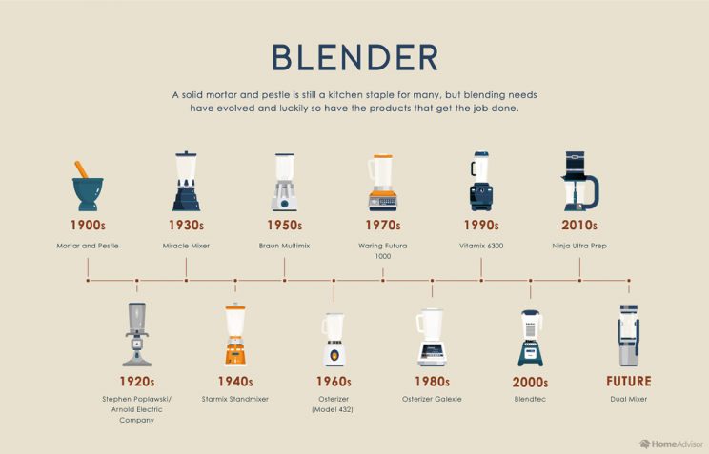Source: Home Advisor
Before the invention of the blender as an appliance in 1922, people used to have to break down and mix things by hand. Apart from being utterly inconvenient, this process was commonly practiced with mortar and pestles. Making a smoothie wasn't really a thing back then, at least in the lens of modern context.
In the 1930s, an appliance called the Miracle Mixer came along. This device iterated on the first invention of the blender and made it accessible to the public.
Early blenders were basically just cups with spinning blades in the bottom, but modern blenders now have all the tech in the world.

Sokovnik
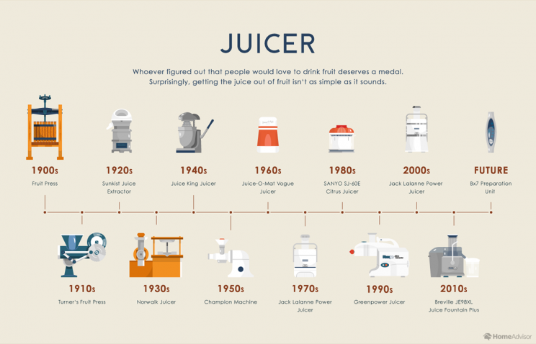Source: Home Advisor
As the Industrial Revolution took over in the U.S., pressing your own fruit for juice by hand became so last century. By 1915, the first mechanical fruit press was created, which led way to the Sunkist Juice Extractor, sold in the 1920s. This early juicer popularized the practice in the U.S.
Over the years, the main thing that changed about juicing machines was just how they extracted the liquid from the fruit. Early machines emulsified the fruit and filtered out the pulp. As time went on though, researchers discovered that these high-intensity machines could break down some of the beneficial nutrients from the fruits.
Today, most juicers use a twin-gear system that squeezes out the juice and keeps the nutrients intact.

Toaster
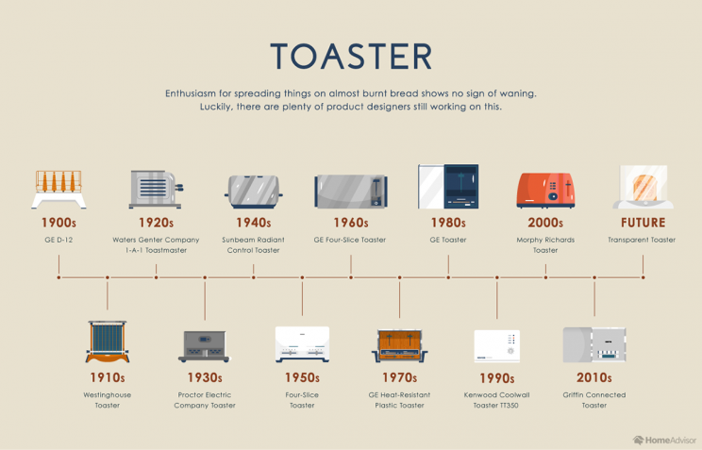Source: Home Advisor
Ah, the simple toaster... how much could that have changed over the years? 1909 was the first year that a commercially successful toaster was sold, called the D-12 from GE. This toaster was one that surely would catch your house on fire as it was essentially just heated exposed coils that you would set your bread in to toast.
As time moved on and houses undoubtedly burned, many different companies iterated on the original toaster design. By about the 1920s we started seeing toasters that were fully enclosed and much safer to use.
Believe it or not, it wasn't until Wonder Bread began selling pre-sliced bread loaves in the 1930s that the toaster rose to prominence as being a breakfast-making machine, according to Home Advisor.

Grelnik vode
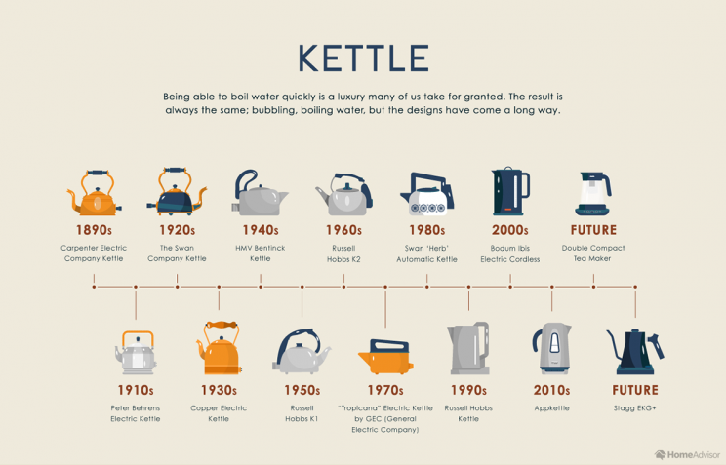Source: Home Advisor
Kettles, like toasters, are another appliance that didn't really need a ton of improvement to bring it into the modern era. Early kettles were simple metal pots that would be placed over gas stoves. Believe it or not, by the 1890s, the world already had an electric kettle that could heat water by being plugged in.
After this innovation, kettle designs were essentially just slowly improved upon as even the most advanced kettle tech today is still just an electric kettle.

Pomivalni stroj
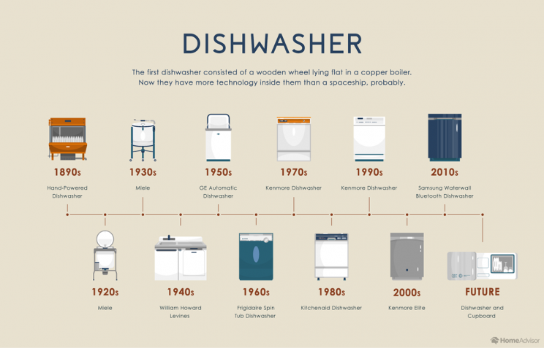Source: Home Advisor
Dishwashers changed the world. First introduced in the 1890s as a hand-powered machine, the importance of these magical kitchen devices grew over the years. Permanent plumbing as part of home construction in the 1920s is part of what caused the use of these machines to increase as more and more homes could be built with a place for a dishwasher.
It really wasn't until the 1940s and 50s that dishwashers became the machine that we know and love with racks and spinning sprays. Other than new engineering tech, the core design really hasn't changed much since then.

Štedilnik
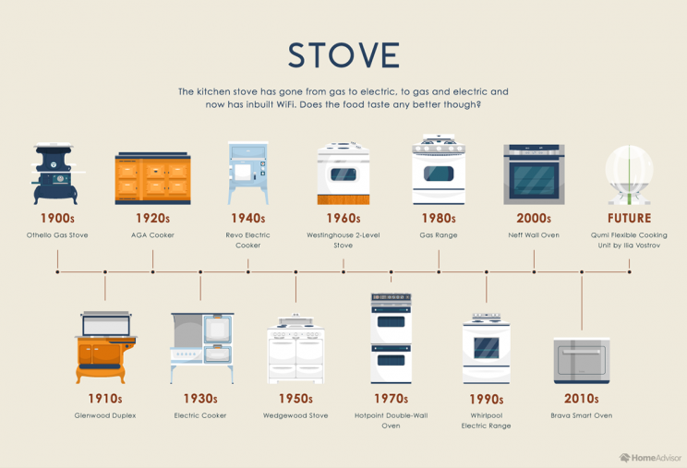Source: Home Advisor

Cooking before the modern stove meant using fire. Early stoves were just metal casings that contained burning wood and directed the heat to a cooking surface. In 1900 the first gas-fueled stove was introduced.
Gas would dominate the stove industry for nearly the next 3 decades until electric ovens were offered up as a safer and easier alternative.
Stoves then started evolving from purely pieces of function into modern aesthetic works of art.

Ekonom lonec
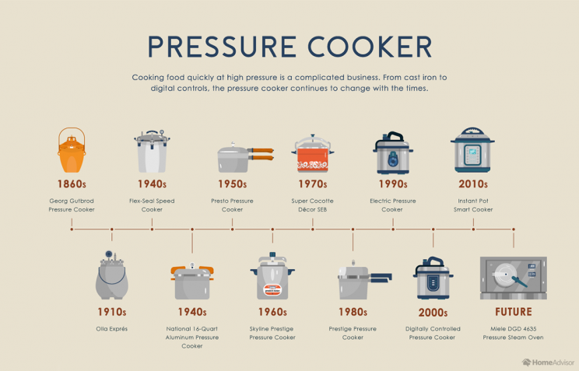Source: Home Advisor
Pressure cooking was first experimented with in 1679 but really wouldn't become a cooking method of popularity until the second World War. This was due to pressure cookers allowing for lower fuel usage, making them far cheaper to cook with.
This appliance is one that really peaked in the mid-1900s and has been on the decline in use ever since. Nowadays we have appliances like the Instant pot that work to prepare out meals, but in general, we let our quick-cooking get done by the friendly microwave.
If you want to take a look at the evolution of each appliance side-by-side, take a look at the infographic below.

