Where's Spot? (Učni list 3)
- Poslušaj in s pomočjo sličic sestavi povedi.
 |  |  | 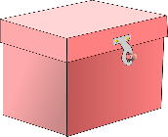 |  | 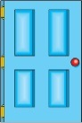
 | IN  IN | UNDER  ON  ON | UNDER | BEHIND  BEHIND

is
is
is

- Preberi in s pomočjo sličic sestavi povedi.
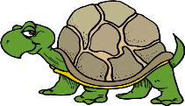 |  | 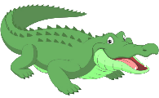 | 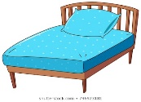 |  | 
 | INSIDE  IN | UNDER  ON  ON | UNDER | BEHIND  BEHIND
The hippo is in the piano.
is

The tortoise is under the rug.
is

The crocodile is under the bed.
is



- Poslušaj in dopolni povedi.
The monkey is __________ the wardrobe.

The tortoise is __________ the rug.

__________ is ___________ the stairs.

___________ is ___________ the door.

The hippo is _________ _____________.

The penguin is __________ ____________.

- Poslušaj in zapiši povedi.

