
Spot's Song? (Učni list 4)
- Poslušaj in zapoj pesmico na melodijo »Če študent na rajžo gre« ter jo po vzoru dopolni s svojim besedilom. Lahko si pomagaš s sličicami ali dodaš svoje besede.
Is | the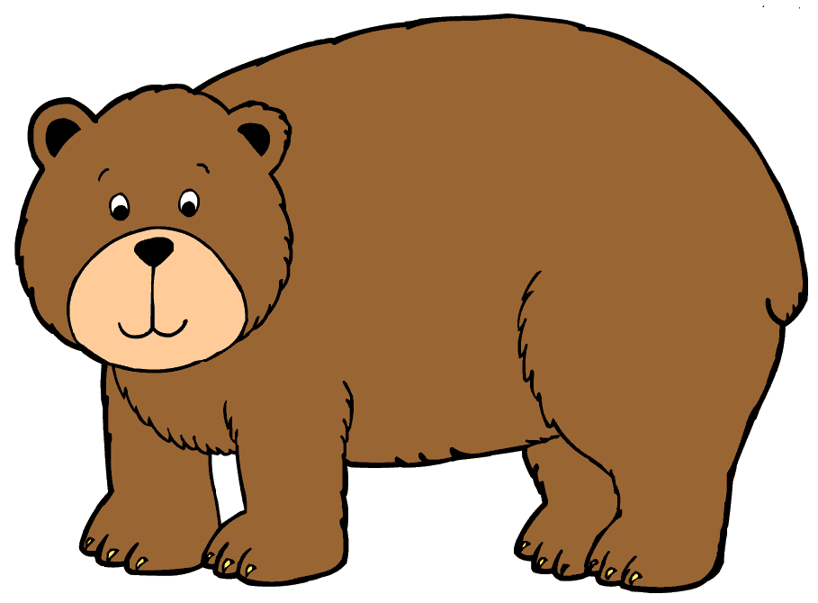 |  | the 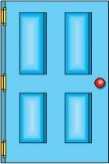 | 
Is | the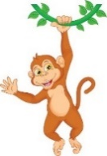 |  | the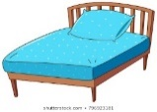 | 
Is | the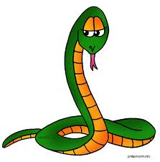 |  | the
Is | the |  | the

Is | the |  | the
Is | the |  | the
Is | the |  | the
Is | our 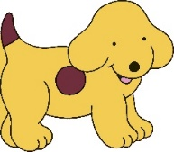 |  | the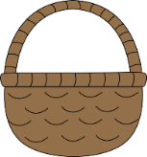
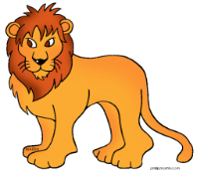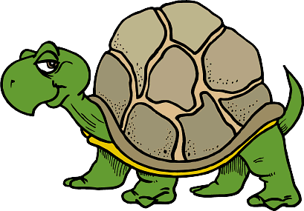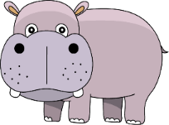
SPOT’S SONG
Is the bear behind the door? Yes, he is, yes, he is.
Is the monkey on the bed? No, he isn’t, no, he isn’t.
Is the snake inside the clock? No, he isn’t, no, he isn’t.
Is the croc behind the bed? Yes, he is, yes, he is.
…
…
…
Is our Spot inside the basket? Yes, he is.
