IGRA SPOMIN
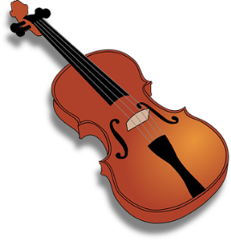
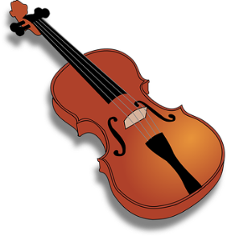
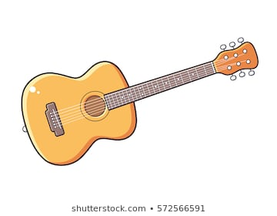


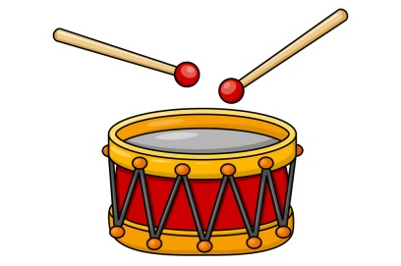

1
2
3

4

5

6

7
9
8

2
5
14
10
6
9
7
15
13
16
12
8
11
4
3
1
V
V
V
V

2 | G | E | 5
C  5 | 3  6 | H  8  7 | 0
6  9 | CIS  10 | D  11  12 | 4
A  13 | 7  14 | FIS  15  16 | 1
1
4
3
2

0  1  2  3  4 | AS | ES | 5
B  5 | 6  7  6 | DES  8 | 1
3  9  10 | GES  11 | F  12 | 7
C  13 | 4  15  14 | CES  16 | 2

1
4
3
2
a  5 | B | G | g
D  6 | gis | F  11  8  7 | fis
cis  10  9 | C | E  12 | h
A  13 | e  14 | H  15  16 | d

2
1
12
p | glasno  3 | mf | allegro  4
mp  10  9  5  6 | adagio  11 | andante  7  12 | srednje tiho  8
upočasnjuj | tiho | f | zmerno
veselo  14  13  hitro | rit.  15 | srednje glasno | počasi  16

b  1  4  3  2  6 | ES | GES | ais
B  9  5 | as  10  7 | FIS  11  8 | f
dis  13 | CIS  14 | CES | c  12
AS | g | DES  16  15 | es

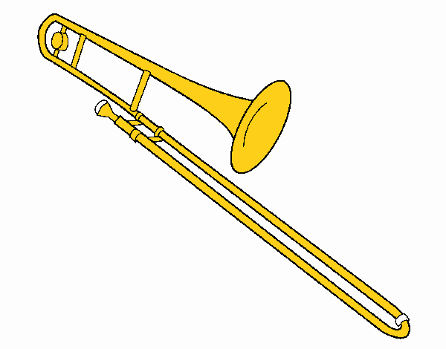
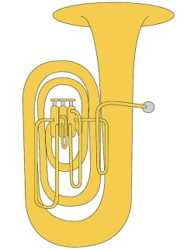
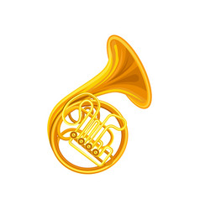
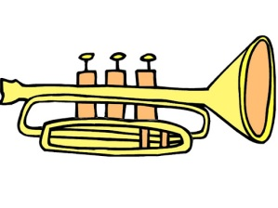
3
1
2
9
8
6

5

4
7

